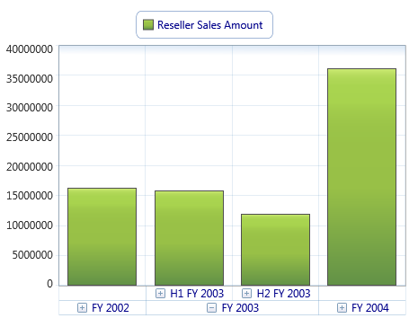

MarkerString2

MarkerString3

#BI_CHART_PLACEHOLDER#

